Section 1

- Write a structural verilog module for 1 bit full adder
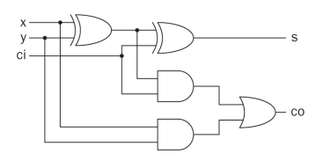
- Using the module you created in (a), write another module to form a 3 bit full adder
Use 6 inputs of 1 bit
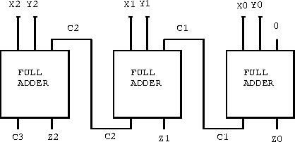
- Write a testbench to compute 101 + 011 = 1000

module one_bit_full_adder(x,y,ci,s,co)

input x,y,ci;
output s,co;
wire o1,o2,o3;

xor g1(o2,x,y);
xor g2(s,o2,ci);
and g3(o1,x,y);
and g4(o3,o2,ci);
or g5(co,o2,o3);

endmodule

module three_bit_full_adder(x,y,num)

input [2:0] x,y;
wire [2:0] c;
output [3:0] num;

one_bit_full_adder a1(x[0],y[0],0,num[0],c[1]);
one_bit_full_adder a2(x[1],y[1],c[1],num[1],c[2]);
one_bit_full_adder a3(x[2],y[2],c[2],num[2],num[3]);

endmodule

module tb();

reg [2:0] x,y;
wire [3:0] num;

three_bit_full_adder UUT(.x(x), .y(y), .num(num));

initial begin

x = 3’b101;
y = 3’b001;

end

endmodule

Section 2
- Write a dataflow verilog module for 1 bit half adder
- Write a dataflow verilog module for 1 bit full adder
- Using the modules you created in (a) and (b), write another module to form a 4 bit full adder
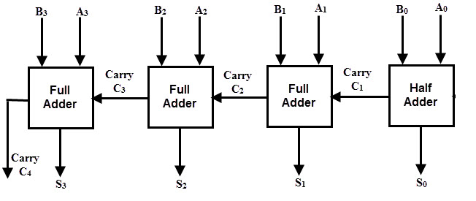
- Write a testbench to compute 1010 + 1100 = 10110

Section 3
- Write a dataflow verilog module for a 1 bit half adder
- Write a dataflow verilog module for a 1 bit full adder
- Using the modules you created in (a) and (b), write another module to form a 4 bit full adder that finds summation of A and B, then S and X.
- Testbench: A+B=S=1110 S+X = 11000
A = 0101
B = 1001
X = 1010

